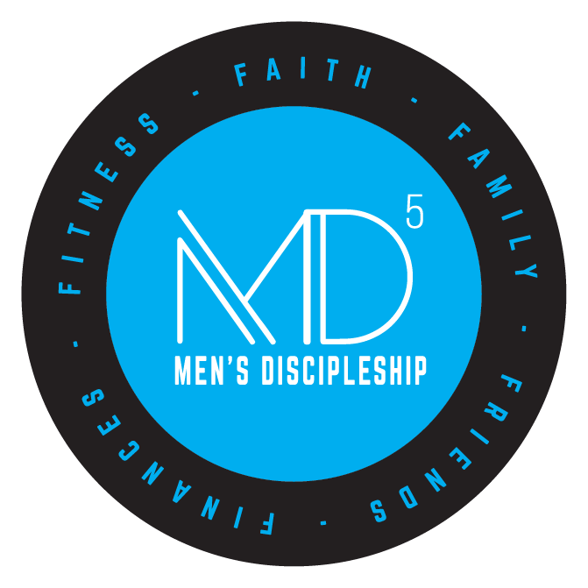

The Next Step
Facilitator’s Notes

Table of Contents

MD⁵ Final Wrap-Up Session …………..……… ……………………………………….….…5

MD⁵ – What Now? ………..……………………………………………………..……………..9

MD⁵ – The Final Charge ……………………..…………………………….….……………..11

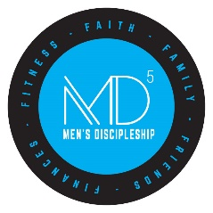
MD⁵ Final Wrap-up Session

The Man I Am vs. the Man I Want to Be
Nearly a year ago, we began a spiritual journey together. Before we could strike out on this journey, we had to determine two important things. Like a GPS, we needed to know where we were starting and where we were ending and then and only then, could we plot the route to take.

To determine where we are starting our journey, we took an assessment focusing on the following seven areas of our lives: Biblical Manhood, Family, Friends, Fitness, Finance, Faith, and Margin & Habits. For some of us, this was an eye-opening experience as we realized that we were not as strong in some areas of life that we thought we were.

Next, we needed to determine our destination – where we wanted to be. We accomplished this by writing our own eulogy – what we wanted someone to truthfully say about how we lived our life on the day of our funeral. It became abundantly clear that there was a gap between where we presently are and where we want to be. The gap between where we are today, and where we want to be at the end of the life, is what MD⁵ focuses on.

To navigate the journey between where we presently are, and where we want to be at the end of our lives, we developed a Life Plan for each of the 5 Fs (Family, Friends, Finances, Fitness, & Faith) – the one thing that we will do in the coming year in each area of the 5Fs. The focus of some discipleship programs is content – a focus on information. The focus of MD⁵ is a Life Plan – a focus on transformation of lives.

The Man I Am vs. the Man I Want to Be.

Life’s Brevity
The Bible refers to the shortness of life by describing life as “a few days” (Job 14:1) that “are soon gone” (Ps. 90:10). Moses (Ps. 90:5,6), Job (Job 14:2), Isaiah (Isa. 40:6–8), James (James 1:10), and Peter (1 Pet. 1:24,25) all described the fleeting nature of human life like grass and flowers that quickly wither and die. Both Job and the psalmist described the length of man’s life as a “breath” (Job 7:7; Ps. 39:5,11). James reminded boastful men, “… you are a mist that appears for a little time [on a frigid day] and then vanishes” (James 4:14) almost as quickly as it formed.

But most of us do not realize how short life really is until we reach the fourth quarter of our life. And by then, our life is nearly over and we have only a limited time left to focus on what’s really important in life. Due to the brevity of life, Moses prayed: “So teach us to number our days that we may get a heart of wisdom.” (Ps. 90:12) This should be our prayer too. Not just to count every day but to make every day count!

When he was in his eighties, evangelist Dr. Billy Graham (1918-2018) was asked by a reporter what had surprised him most about life. Without hesitation, Dr. Graham replied, “Its brevity.” It is certainly no exaggeration to say that the older we get the faster time appears to pass and before we know it, life is over. Therefore, it is imperative that today we take control of every day of our life and invest these days in the things that are truly important.

Life’s Brevity

Begin With the End in Mind
Author Francis Chan made this observation, “The happiest man is he who is able to integrate the beginning of his life with the end.” Is he speaking about your life? He could very well be because we have given you the tools in MD⁵ to do exactly that – begin with the end in mind.

We have challenged you this year to live your life on purpose. Not merely with good intentions but by living intentionally. We have identified one of life’s greatest dangers as focusing on the urgent things of life at the expense of the important things of life. We have focused on the Great Commission (Matt. 28:18-20) and God’s calling upon all our lives to become “Great Commission” Christians. Since only mature believers spiritually reproduce themselves – become spiritual parents – the call to fulfill the Great Commission is actually a call to spiritual maturity.

As has often been said, “When everything is said and done, more is often said than done.” MD⁵ is not about saying what we will do – it is about doing what we say. On the Day of Judgment, God will not say, “Well said,” or “Well thought out,” or “Well planned.” He will say to those who are faithful, “Well done.”

Like everything that is worthwhile in life, there is a cost to discipleship. But have you considered the cost of non-discipleship? When we walk the streets of Gold in Glory, none of us will say on that day that we gave too much, sacrificed too much, etc. We will all wish we had given more.

Most of you didn’t know each other when we started our journey nearly a year ago. There has been a lot of life lived by the men sitting in this room. Even this year, there have been a lot of changes—job changes, the loss of friends and family members, illnesses, and we have celebrated the accomplishments of our children together.

The goals of MD⁵ from the beginning have been to:
- Identify and then pursue God’s will for your life.
- Build margin into your life so you can build a larger network of like-minded Christian men.
- Create plans to build one new habit per F each year.
- Continue to grow personally in your faith.
- Equip you to better share your faith with others.
- Help you those others around you closer to Christ.

The challenge you take with you when you walk out the door today is to create a sustainable system that will turn your Life Plan into life habits. Godly habits are the key to true life change.

Begin With the End in Mind

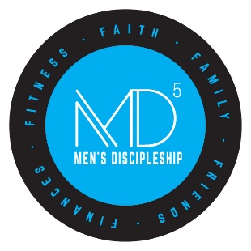

MD⁵ – What Now?

Though you have now completed MD⁵, the spiritual journey has just begun. Since our quest is to continually be conformed to the image of Christ in every area of our lives, our ultimate goal is not a destination but a journey. This journey will be filled with challenges and obstacles, and the enemy will do all in his power to distract us.

Consequently, for us to live out our Life Plans, we need to be in a community of believers that will both challenge us and encourage us to press on to fulfill God’s will for our lives. To that end, you will be assigned an accountability group that will meet monthly over breakfast to discuss the progress you are making with your Life Plan. Since this effort will be a lifelong journey, your Life Plan cannot be stagnant but rather dynamic. You should be ever changing as the Holy Spirit continually molds you into the person God would have you be.

The accountability group exists to help you continue to grow; however, remember you are laborers in God’s Kingdom and should also start a discipleship group of your own to help others grow in their faith. Thus, you should be part of a “Barnabas” accountability group where others are encouraging/investing in you and part of a “Paul” discipleship group where you are encouraging/investing in others. It has been rightly said, “We are better together.”

MD⁵ – The Final Charge

As we explained in our very first meeting and every week since, MD⁵ is a simple process to bridge the gap from the men we are today to the men we want to be in the future. We culminated the MD⁵ effort with a written Life Plan that will enable you to live with intentionality and fulfill God’s plan for your lives. The plan is a simple bridge from the man you are today to the man God has called you to be. Here are a few final, guiding thoughts to remember:

- Remember, we don’t rise to the level of our goals, we fall to the level of our systems.

Your Life Plan provides a system for you to pursue and accomplish God’s will for your lives by living everyday with intentionality, focused on actions that center on your Top 5% (those things that only you can do).

- Further, remember that we “steer where we stare.”

As Christ followers, it is imperative that we keep our eyes on Jesus and his will for our lives. He made his will crystal clear in the Great Commandment (Matt. 22:37-40) and in the Great Commission (Matt. 28:18-20).

- The Great Commandment demands that we love God with our heart, mind, and soul—that is our entire being (Matt. 22:37-40).

God’s will and his work should take precedent over every other matter in life. The Great Commission demands that we make disciples who make disciples (Matt. 28:18-20; 2 Tim. 2:2). This is God’s primary plan for reaching the world, and there is no “Plan B.” The goal of the MD⁵ discipleship ministry is not to make disciples—it is to make disciple makers!

Jesus said to His disciples, “The harvest truly is plentiful, but the laborers are few. Therefore, pray the Lord of the harvest to send out laborers into His harvest.” (Matt. 9:37-38 ESV)

Above all, remember, you are a laborer in God’s Kingdom and it is harvest time!

The final question we have for you is this: “Will you take what you have learned and how you have changed forward?” If not you, then who? If not now, then when? If not here, then where? Others have invested in your life with the prayer that you will in turn invest your life in the lives of others. Don’t let them down. Better still, don’t let the Lord down! The life-on-life discipling process is the church’s only hope! Who do you know that needs what you have learned this year in MD⁵? There is someone you know who needs this!

